Subject- Can we export an LWR page to a template to use it as base page to create new pages of the experience site?

Description- I am looking for Developer options, which is, present in AURA template but not present in LWR template under experience builder.

From Experience Builder under Aura template under Setting there is an option of a developer from where I can Export a page but when I am looking into the setting of LWR experience builder then there is no feature of developer or export a page So I want to get that feature in LWR template. I am attaching the Screenshot of both Templates.

This Image is of Aura template

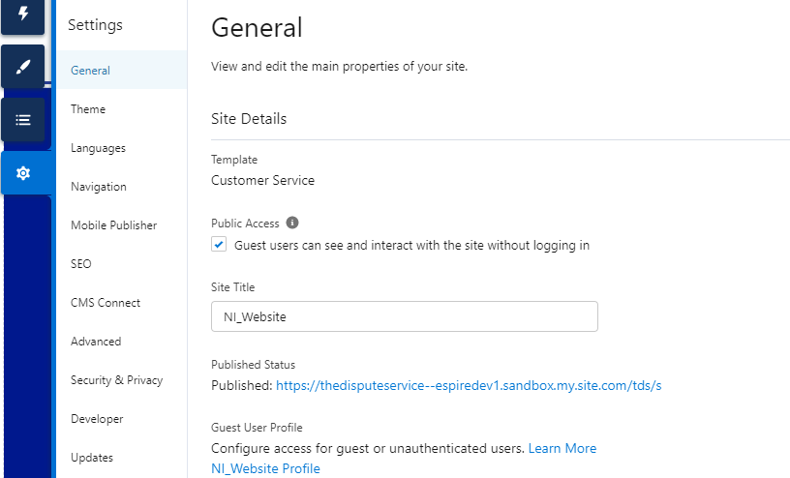

Above Image with developer which is second last. which is not present in LWR template.

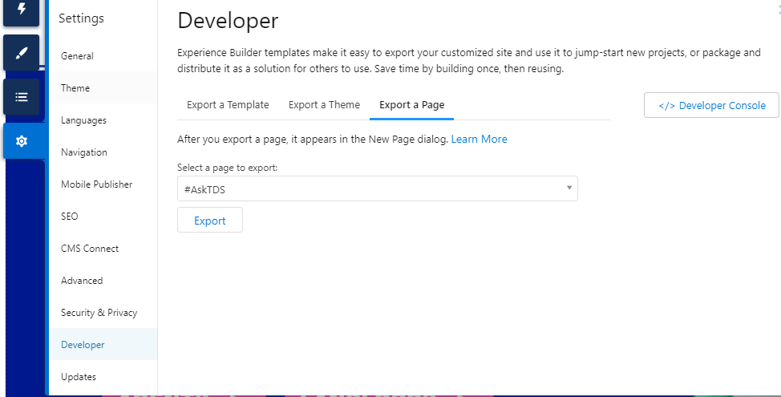

Below image is from LWR template

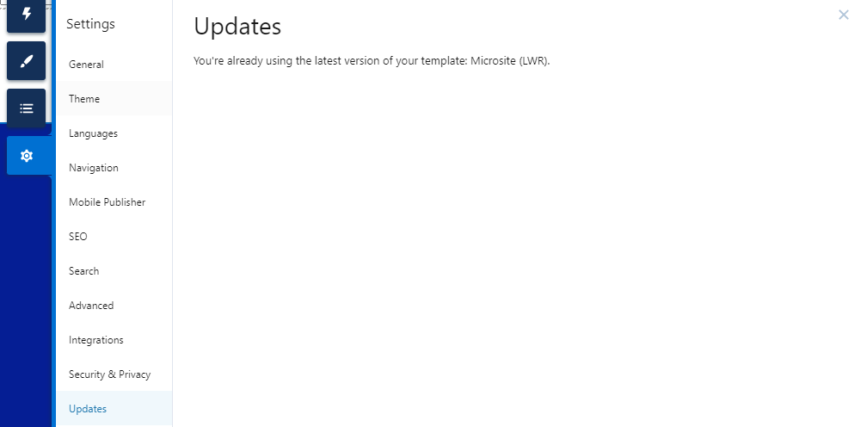

Above image with no option of developer

Primary Contact email- [harsh.bansal@espire.com](mailto:harsh.bansal@espire.com) , Contact No + 91-9971477305

Alternative contact email [Deepti.kataria@espire.com](mailto:Deepti.kataria@espire.com) , Contact No +91-9873576323